EXPERIMENT-1 .
- AIM:
To acquire data from multiple sources and perform data profiling using Microsoft Power BI in order to assess data quality, understand data structure, identify anomalies, and prepare data for further analytical processing.

- OBJECTIVES:
- To understand the basic concepts of Business Intelligence and data acquisition.
- To acquire data from multiple heterogeneous sources such as CSV, Excel, and SQL Server.
- To import and integrate different datasets into Microsoft Power BI.

- TOOLS / SOFTWARE REQUIRED:
  - Microsoft Power BI Desktop
  - Sample datasets: Sales_Data.csv, Employee_DB.xlsx, and a sample SQL database

- DATASET USED: Sales_Data.csv, Employee_DB.xlsx, Transactions.sql

- THEORY:
Business Intelligence (BI) refers to the technologies, methods, and practices used by organizations to collect, process, analyze, and interpret business data for better decision-making. BI combines multiple components, including data sources such as databases, spreadsheets, cloud applications, files, and APIs, which provide the required information. This data is then processed through ETL (Extract, Transform, Load), where it is collected, cleaned, modified, and prepared for analysis. The processed data can be stored in a data warehouse or data lake, depending on its structure and intended use. BI platforms such as Microsoft Power BI provide tools for transforming data, creating visualizations, and generating meaningful reports. BI also supports different levels of analytics, including descriptive analysis to understand past events, diagnostic analysis to identify their causes, predictive analysis to estimate future outcomes, and prescriptive analysis to recommend suitable actions. An important step before analyzing data is data acquisition, which involves collecting information from different sources and bringing it together into a common environment. In Power BI, this can be done using the Get Data option, which allows users to connect to sources such as Excel workbooks, CSV files, SQL databases, online services, and websites. After importing the data, its quality and structure should be examined to ensure that it is suitable for analysis. This process is known as data profiling. Data profiling helps identify the characteristics and reliability of a dataset by checking factors such as completeness, uniqueness, validity, consistency, accuracy, and timeliness. Power BI provides several profiling features within the Power Query Editor, including Column Quality, which identifies valid, blank, and error values; Column Distribution, which displays the frequency of values along with distinct and unique values; and Column Profile, which provides detailed statistics such as minimum, maximum, average, median, and standard deviation for the selected column.

- PROCEDURE:

A. Software Configuration and Data Import
Step 1: Set up the required tools by installing Microsoft Power BI Desktop, SQL Server, and SQL Server Management Studio (SSMS). After completing the installation, open SSMS and check whether the SQL Server instance is running properly. Make sure the required database is available for establishing a connection with Power BI.
Step 2: Open Power BI Desktop and select Home > Get Data > Text/CSV. Navigate to the location of Sales_Data.csv, select the file, preview the data if required, and import it into Power BI.
Step 3: To add the employee records, select Home > Get Data > Excel Workbook. Locate Employee_DB.xlsx, select the appropriate worksheet from the Navigator window, and load the required information.
Step 4: Connect Power BI with the SQL database by choosing Home > Get Data > SQL Server. Provide the server name and database details, select the Transactions table, and import the records. After all imports are completed, check the Data pane to confirm that the three datasets have been added successfully.

B. Data Examination in Power Query
Step 5: To inspect and prepare the imported information, open the Power Query Editor using Home > Transform Data.
Step 6: From the View tab, activate Column Quality, Column Distribution, and Column Profile. Move through the columns individually and observe the profiling information displayed for each one.
Step 7: Examine all three datasets and note the important characteristics of each column, including its data type, number of records, blank values, distinct values, and unique values. For numerical columns, examine additional statistical information such as minimum, maximum, average, and standard deviation. Any errors, unusual entries, or inconsistencies should also be recorded.

C. Detection and Documentation of Data Issues
Step 8: Evaluate the profiling results to determine whether the datasets contain any quality-related problems. Pay particular attention to missing or blank fields, duplicate records, incorrect data formats, text appearing in numerical columns, invalid dates, future dates, and columns containing little or no variation.
Step 9: From the problems identified during the examination, select at least three data quality issues and document them clearly. For every issue, explain the problem and mention an appropriate corrective action, such as filling missing values, removing duplicate records, correcting data types, or modifying invalid entries.

- RESULT
The required data was collected from three separate sources—CSV files, Excel workbooks, and a SQL database—and successfully imported into Microsoft Power BI Desktop for further processing. The Power Query Editor profiling features, including Column Quality, Column Distribution, and Column Profile, were used to evaluate important aspects of the datasets such as completeness, uniqueness, and data validity. The profiling process helped identify various data quality problems, which were recorded along with suitable corrective measures before proceeding with the next stage of analysis
.
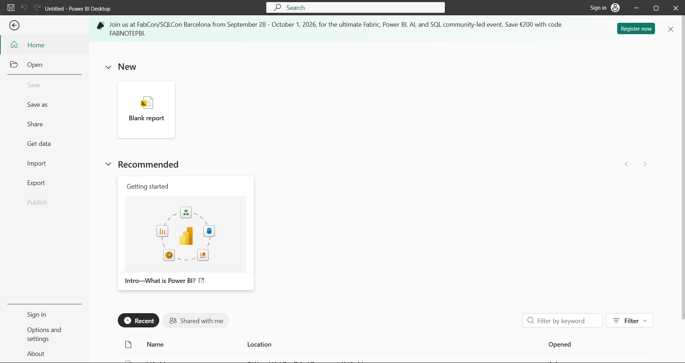

- LEARNING OUTCOMES
  - Understood the concept of Business Intelligence and its role in data-driven decision-making.
  - Learned how to acquire data from different heterogeneous sources.
  - Learned how to import CSV, Excel, and SQL Server data into Power BI.
  - Gained practical experience with Microsoft Power BI Desktop.
  - Learned how to use SQL Server Management Studio for working with SQL-based data.
  - Learned how to use Power Query Editor for data profiling.

